## Practical No : 01

**Aim : To verify Careermate’s functionality using structured manual testing techniques.**

**Testcases :**

|  |  |  |  |  |  |  |  |  |
| --- | --- | --- | --- | --- | --- | --- | --- | --- |
| **Sr. No** | **Test ID** | **Action** | **Description** | **Input** | **Expected Output** | **Actual Output** | **Test Result** | **Test Comment** |
| 1 | register_01 | User Registration | Test new user sign-up flow | Valid username , email, password | Account should be created and should redirect to dashboard/log in | Success message is shown | Pass | Working as expected |
| 2 | register_02 | Duplicate Registration | Check for duplicate email during registration | Already registered email | System should show “Email already exists” error | Error message is shown | Pass | Validation enforced |
| 3 | login_0 1 | Login with valid credentials | Authenticate with correct credentials | Correct email and password | System should redirect to dashboard | User is redirected successfully | Pass | Login successful |
| 4 | login_0 2 | Login with invalid credentials | Block incorrect login attempts | Wrong password | System should show “Incorrect credentials” error | Error message is shown | Pass | Login validation working |
| 5 | login_0 3 | Forgot Password | Test password recovery process | Registered email address | System should display reset instructions or should send reset email | Message is shown | Pass | Flow implemented correctly |
| 6 | login_0 4 | Logout | Verify logout clears session | Click logout button | System should redirect to login page | Logout is successful | Pass | Session cleared |
| 7 | job_01 | View Jobs | Display job listings after login | Click “Jobs” tab | System should show available job listings | Listings are visible | Pass | Display correct |
| 8 | job_02 | Search Jobs | Verify job search/filter works | Search keyword (e.g., React Developer) | Filtered job list should be shown | Filter results are accurate | Pass | Search functional |
| 9 | job_03 | Apply to Job | Apply to selected job | Click “Apply” | System should show confirmation message or should move to “Applied” section | Confirmation is shown | Pass | Apply logic verified |
| 10 | resume_01 | Upload Resume with valid file | Upload a valid resume file | Upload PDF file | System should show “Resume uploaded successfully” | Upload is successful | Pass | Functional |
| 11 | resume_02 | Upload Resume with invalid file | Prevent upload of unsupporte d file types | Upload .exe, .js file | System should show “Invalid file type” error | Error message is shown | Pass | Security check passed |
| 12 | profile_ 01 | Update Profile | Edit user details and save | Change name, skills, contact info | Updated profile should be displayed | Changes are saved | Pass | Update working |
| 13 | security_01 | Unauthorized Dashboard Access | Prevent access without login | Visit dashboard URL without login | System should redirect to login page | Redirect is successful | Pass | Access control functional |
| 14 | uiux_01 | Mobile View | Check layout responsive ness | Open in mobile browser/e mulator | Layout should adjust without breaking | Responsive layout is visible | Pass | Mobile-friendly verified |
| 15 | admin_ 01 | Admin Login | Admin authenticati on with correct credentials | Valid admin login | System should redirect to admin dashboard | Admin is logged in | Pass | Admin role verified |
| 16 | admin_ 02 | Admin Adds Job | Test job posting via admin panel | Fill job form and submit | Job should appear in job listings | Job is listed | Pass | Create functionality works |
| 17 | admin_ 03 | Admin Deletes Job | Remove a job posting from system | Click delete on a job | Job should be deleted from DB and UI | Job is removed | Pass | Delete logic confirmed |

## Practical No : 02

**Aim : Implement web drivers on chrome and Firefoxbrowser(chrome, Firefox,choose browser)**

**CODE :**

**package** com.gh;

**import**org.openqa.selenium.WebDriver; **import**org.openqa.selenium.firefox.FirefoxDriver;

**publicclass** l {

**publicstaticvoid** main(String[] args) {

System.*setProperty*("webdriver.chrome.driver","C:\\selenium web driver\\ChromeDriver\\chromedriver-win64\\chromedriver-win64\\geckodriver.exe");

WebDriverwd = **new**FirefoxDriver(); wd.get("[http://google.com](http://google.com/)");

}

}

1. **Chrome**

**OUTPUT :**

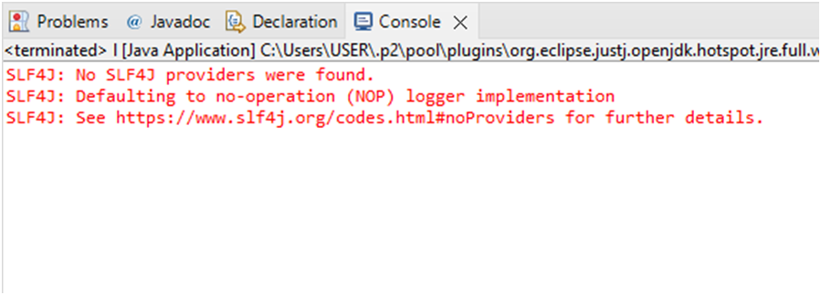

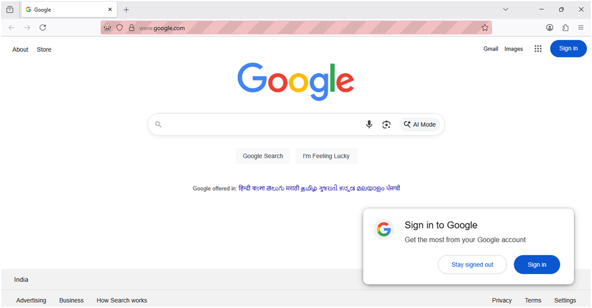

1. **FireFox CODE :**

package com.prac2;

import org.openqa.selenium.WebDriver;

import org.openqa.selenium.firefox.FirefoxDriver;

public class Practical2 {

public static void main(String[] args) {

System.setProperty("webdriver.chrome.driver","C:\\selenium webdriver\\ChromeDriver\\chromedriver-win64\\chromedriver-win64\\geckodriver.exe");

WebDriver wd = new FirefoxDriver(); wd.get("[http://netlify.com](http://netlify.com/)");

}

}

**OUTPUT :**

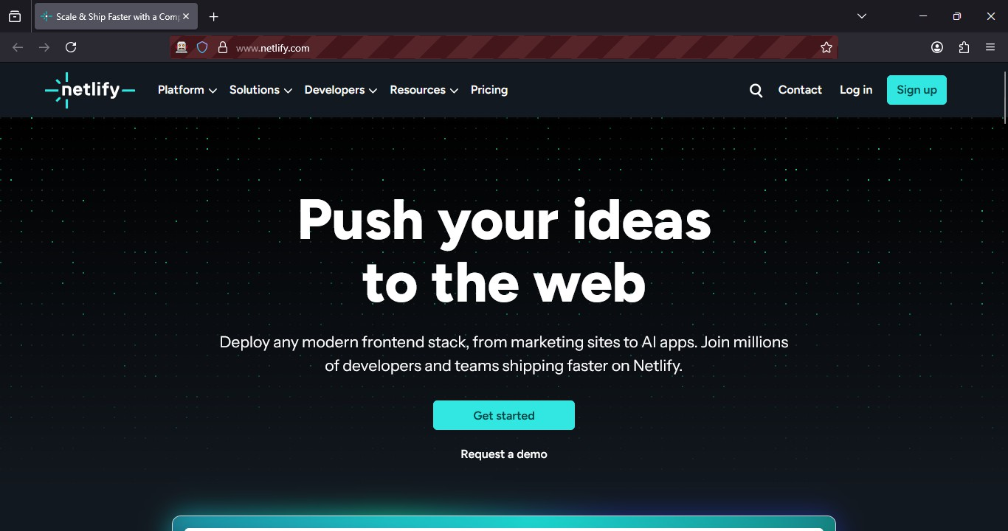

1. **Any Browser**

|  |
| --- |
| package prati;  import java.util.Scanner;  import org.openqa.selenium.WebDriver;  import org.openqa.selenium.chrome.ChromeDriver;  import org.openqa.selenium.firefox.FirefoxDriver;  public class Browser {  staticWebDriverwd;  publicstaticvoid main(String[] args) {  Scanner sc = newScanner(System.in);  System.out.println("Welcome");  System.out.println("1.Chrome\n2.Firefox\n");  System.out.println("Choice");  intch = sc.nextInt();  sc.close();  switch (ch) {  case 1:  System.setProperty("webdriver.chrome.driver", "C:\\selenium web driver\\ChromeDriver\\chromedriver-win64\\chromedriver-win64\\chromedriver.exe");  wd = newChromeDriver();  break;  case 2:  System.setProperty("webdriver.chrome.driver", "C:\\selenium web driver\\ChromeDriver\\chromedriver-win64\\chromedriver-win64\\geckodriver.exe");  wd = newFirefoxDriver();  break;  default:  System.out.println("Invalid Choice");  }  if (wd != null) {  wd.get("http://figma.com");  }  }  } |

**OUTPUT :**

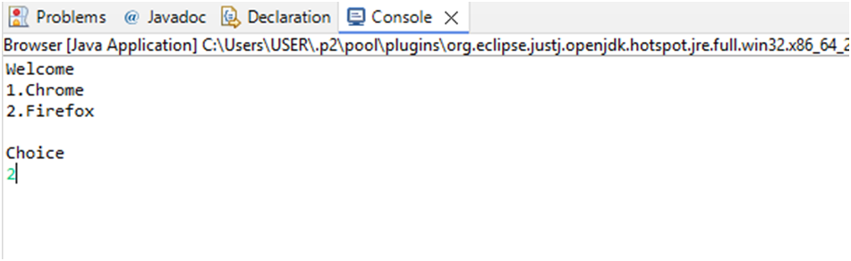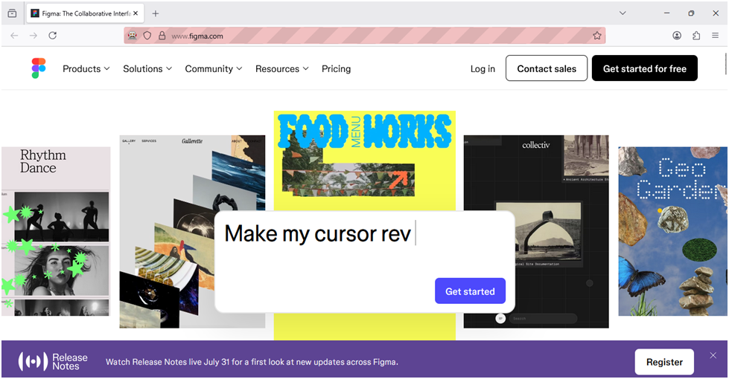

**Practical No : 03**

# **Aim : Demonstrate wait command in selenium.**

# **Code :**

package lathika98;

import org.openqa.selenium.By;

import org.openqa.selenium.WebDriver;

import org.openqa.selenium.firefox.FirefoxDriver; import org.openqa.selenium.support.ui.Select;

import org.openqa.selenium.support.ui.WebDriverWait; import org.openqa.selenium.support.ui.ExpectedConditions;

import java.time.Duration; public class OrderPlace {

public static void main(String[] args) {

//Set path for GeckoDriver (Firefox)

System.setProperty("webdriver.gecko.driver", "C:\\selenium web driver\\ChromeDriver\\chromedriver-win64\\geckodriver.exe");

WebDriver wd = new FirefoxDriver();

// Open the demo FrontAccounting site wd.get("https://demo.frontaccounting.eu/");

// Wait for elements to load

WebDriverWait wait = new WebDriverWait(wd, Duration.ofSeconds(10));

// Login wait.until(ExpectedConditions.visibilityOfElementLocated(By.name("user_name_entry_field")))

.sendKeys("your_username");

wait.until(ExpectedConditions.visibilityOfElementLocated(By.name("password"))).sendKeys("y our_password");

// Select company (if applicable) Select companySelect = new

Select(wd.findElement(By.name("company_login_name")));

// companySelect.selectByVisibleText("Default Company"); // Uncomment if selection needed

wd.findElement(By.name("SubmitUser")).click();

// Navigate to Sales -> Direct Sales Delivery (for example) wait.until(ExpectedConditions.elementToBeClickable(

By.xpath("/html/body/table[1]/tbody/tr/td/table[1]/tbody/tr/td/div[2]/table/tbody/tr[1]/td/table/tbod y/tr[2]/td[1]/a[1]"))

).click();

// Select a customer

Select customerSelect = new Select(wd.findElement(By.name("customer_id"))); customerSelect.selectByVisibleText("Donald Easter");

// Add item and process order wd.findElement(By.name("AddItem")).click(); wd.findElement(By.name("ProcessOrder")).click();

// Close browser wd.quit();

}

}

**OUTPUT :**

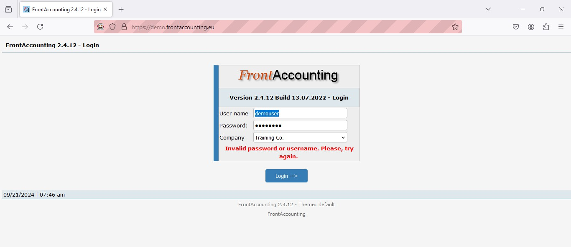

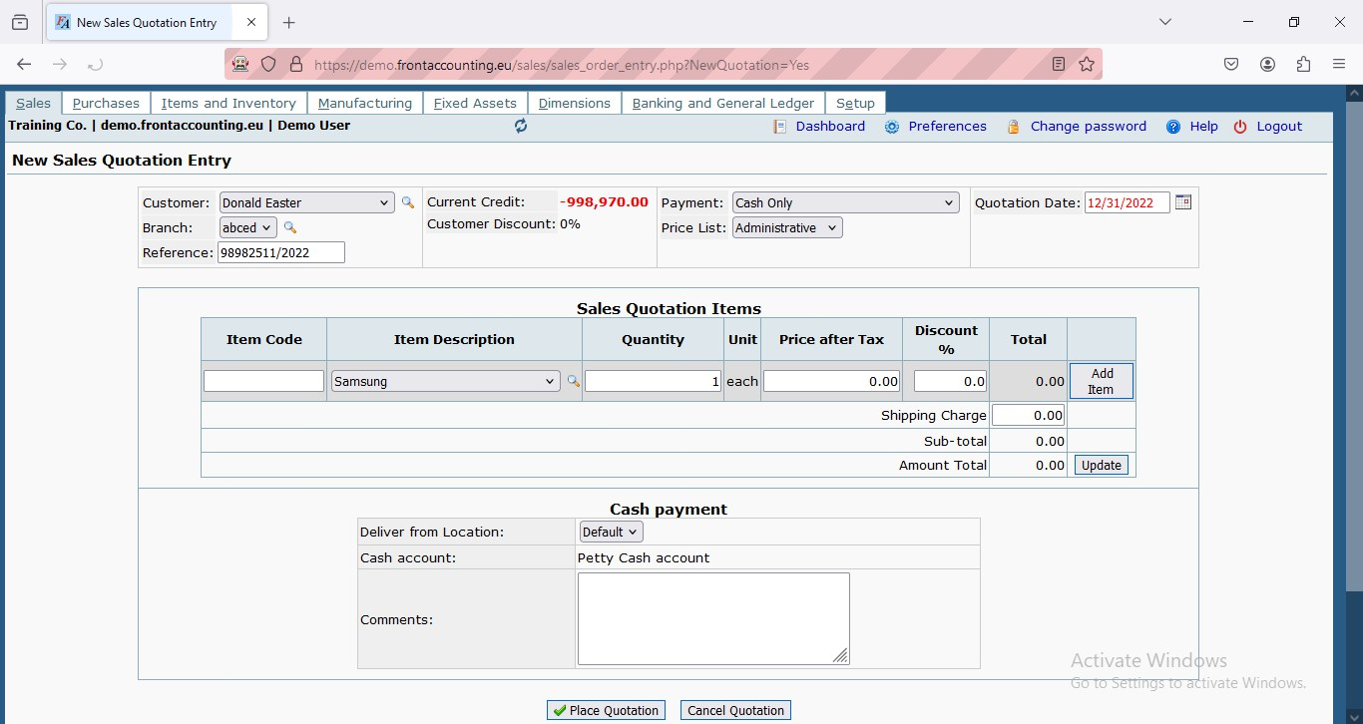

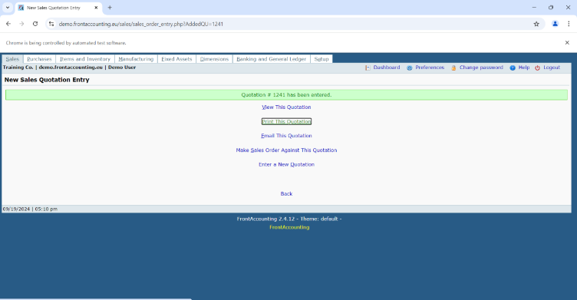

**Practical No : 04**

**Aim : Implement Browser command and Navigation commands**

**CODE :**

package com.prac4;

import org.openqa.selenium.By;

import org.openqa.selenium.WebDriver;

import org.openqa.selenium.firefox.FirefoxDriver; public class Prac4 {

public static void main(String[] args) throws Exception

{

System.setProperty("webdriver.chrome.driver","C:\\selenium web driver\\ChromeDriver\\chromedriver-win64\\chromedriver-win64\\geckodriver.exe");

WebDriver wd = new FirefoxDriver(); wd.get("https://opensource-demo.orangehrmlive.com/"); Thread.sleep(3000); wd.findElement(By.name("username")).sendKeys("admin"); wd.findElement(By.name("password")).sendKeys("admin123");

wd.findElement(By.xpath("//*[@id=\"app\"]/div[1]/div/div[1]/div/div[2]/div[2]/form/div[3]/button")).click(); Thread.sleep(2000);

wd.navigate().back(); Thread.sleep(2000); wd.navigate().forward();

wd.navigate().to("https://opensource-demo.orangehrmlive.com/"); wd.navigate().refresh();

}

}

**OUTPUT :**

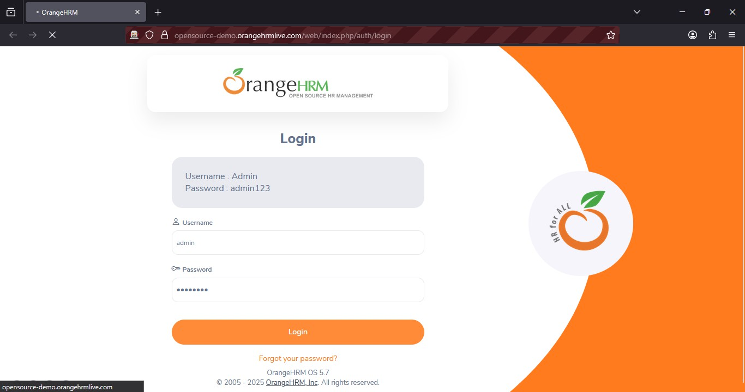

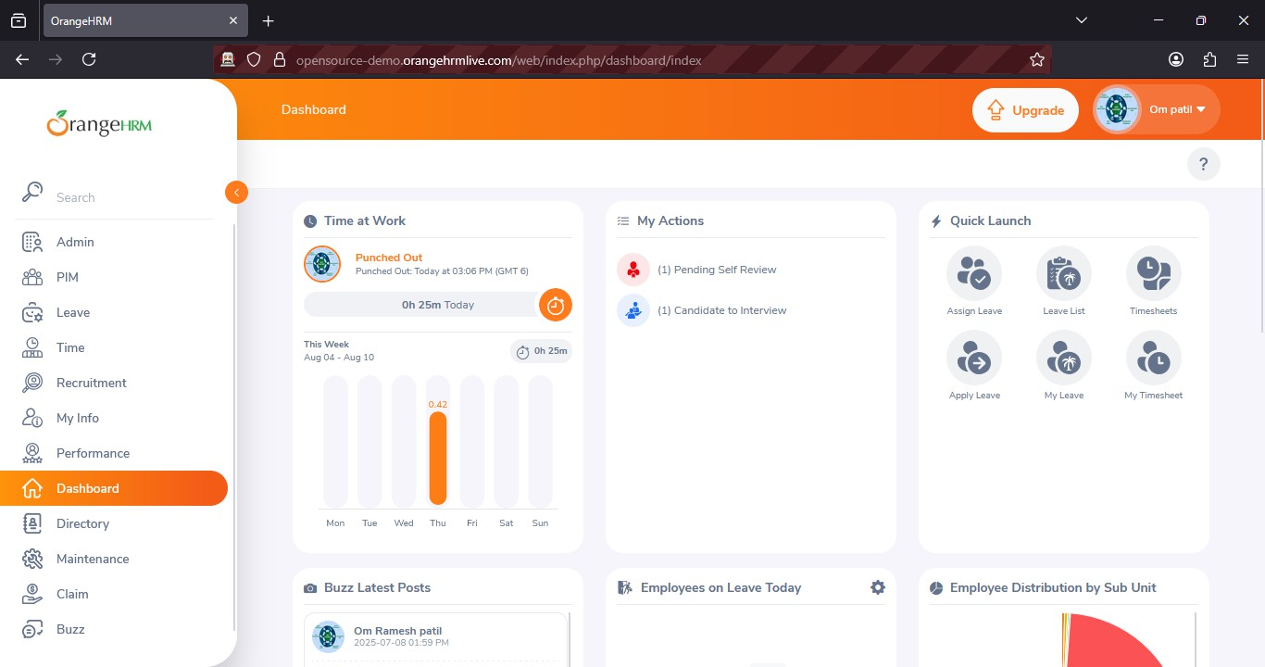

**Practical No : 05**

**Aim : Implement the find element command.**

**CODE :**

package com.prac5;

import org.openqa.selenium.By;

import org.openqa.selenium.WebDriver;

import org.openqa.selenium.firefox.FirefoxDriver; public class Practical5 {

public static void main(String[] args) throws Exception

{

System.setProperty("webdriver.chrome.driver","C:\\selenium web driver\\ChromeDriver\\chromedriver-win64\\chromedriver-win64\\geckodriver.exe"); WebDriver wd = new FirefoxDriver();

wd.get("https://opensource-demo.orangehrmlive.com/"); Thread.sleep(5000);

wd.findElement(By.xpath("/html/body/div/div[1]/div/div[1]/div/div[2]/div[2]/form/div[1]/div/div[2]/input")).sendKeys("ad min"); wd.findElement(By.xpath("/html/body/div/div[1]/div/div[1]/div/div[2]/div[2]/form/div[2]/div/div[2]/input")).sendKeys("ad min123");

wd.findElement(By.xpath("/html/body/div/div[1]/div/div[1]/div/div[2]/div[2]/form/div[3]/button")).click();

}

}

**OUTPUT :**





## Practical No : 6

**AIM: Demonstrate the locator(CSS Selector,Xpath,path)**

**CODE:**

**package** Lathika98;

**import** org.openqa.selenium.By;

**import** org.openqa.selenium.WebDriver;

**import** org.openqa.selenium.firefox.FirefoxDriver;

**public class** CssSelector {

**public static void** main(String[] args) **throws** Exception {

System.*setProperty*("webdriver.gecko.driver", "C:\\selenium web driver\\ChromeDriver\\chromedriver-win64\\chromedriver-win64\\geckodriver.exe");

WebDriver wd = **new** FirefoxDriver(); wd.get("https://opensource-demo.orangehrmlive.com/");

Thread.*sleep*(2000); wd.findElement(By.*cssSelector*("input[name='username']")).sendKeys("admin"); wd.findElement(By.*cssSelector*("input[name='password']")).sendKeys("admin123"); wd.findElement(By.*cssSelector*("button[type='submit']")).click();

}

}

## 1.cssSelector

**OUTPUT :**

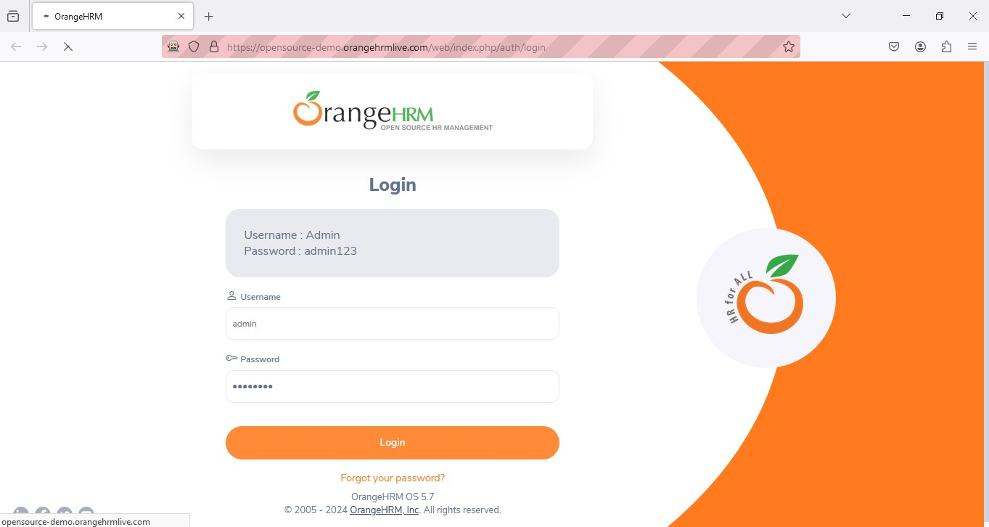

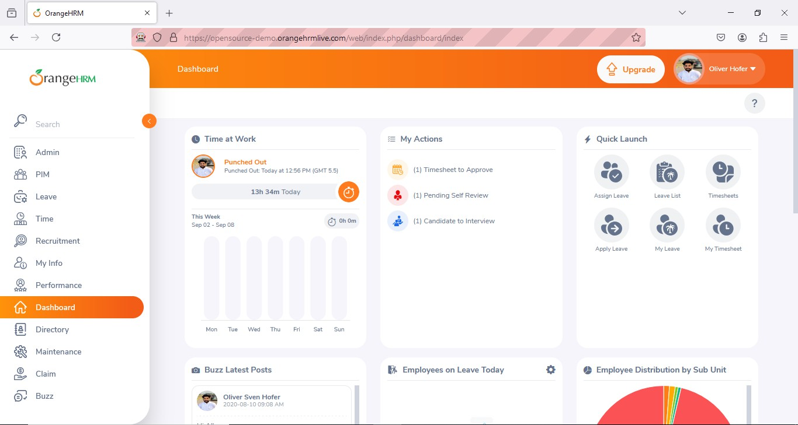

**B. XPath**

package Lathika98;

import org.openqa.selenium.By;

import org.openqa.selenium.WebDriver;

import org.openqa.selenium.firefox.FirefoxDriver;

public class Practical4 {

public static void main(String[] args) throws Exception { System.setProperty(

"webdriver.gecko.driver", "C:\\selenium web

driver\\ChromeDriver\\chromedriver-win64\\chromedriver-win64\\geckodriver.exe"

);

WebDriver wd = new FirefoxDriver(); wd.get("https://opensource-demo.orangehrmlive.com/"); Thread.sleep(5000);

wd.findElement(By.xpath("/html/body/div/div[1]/div/div[1]/div/div[2]/div[2]/form/div[1]/div/div[2]/input")

).sendKeys("admin");

wd.findElement(By.xpath("/html/body/div/div[1]/div/div[1]/div/div[2]/div[2]/form/div[2]/div/div[2]/input")

).sendKeys("admin123");

wd.findElement(By.xpath("/html/body/div/div[1]/div/div[1]/div/div[2]/div[2]/form/div[3]/button")).click();

}

}

## OUTPUT :

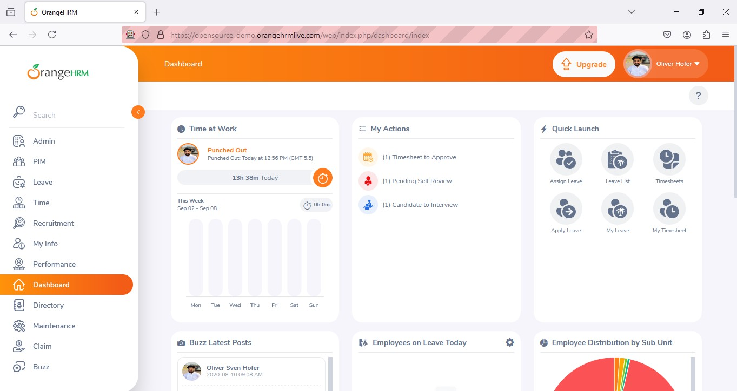

**C. PathSelector**

package Lathika98;

import org.openqa.selenium.By;

import org.openqa.selenium.WebDriver;

import org.openqa.selenium.firefox.FirefoxDriver; // Using Firefox driver

public class pathselector {

public static void main(String[] args) throws Exception {

// Set the system property for GeckoDriver (used by Firefox) System.setProperty(

"webdriver.gecko.driver", "C:\\selenium web

driver\\ChromeDriver\\chromedriver-win64\\chromedriver-win64\\geckodriver.exe"

);

// Initialize the Firefox WebDriver WebDriver wd = new FirefoxDriver();

// Open the OrangeHRM login page wd.get("https://opensource-demo.orangehrmlive.com/");

// Wait for 2 seconds to ensure page loads Thread.sleep(2000);

// Enter username in the username input field wd.findElement(By.xpath("//*[@id='app']/div[1]/div/div[1]/div/div[2]/div[2]/form/div[1]/div/div[2]/input"

))

.sendKeys("admin");

// Enter password in the password input field wd.findElement(By.xpath("//*[@id='app']/div[1]/div/div[1]/div/div[2]/div[2]/form/div[2]/div/div[2]/input"

))

.sendKeys("admin123");

// Click the login button wd.findElement(By.xpath("//*[@id='app']/div[1]/div/div[1]/div/div[2]/div[2]/form/div[3]/button"))

.click();

}

}

**OUTPUT :**



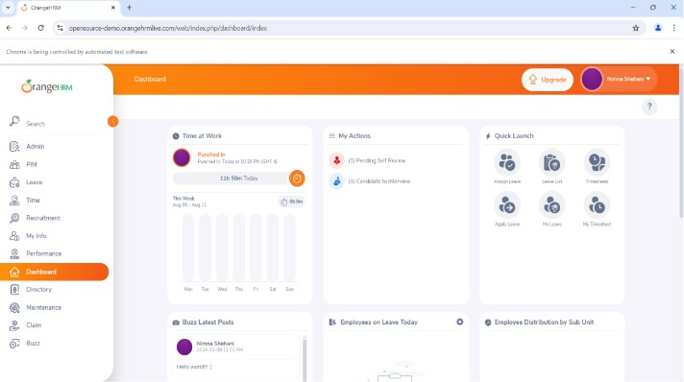

## Practical No : 7

**AIM: Demonstrate Synchronisation in Selenium (Implicity wait,Explicitly wait)**

**A.Implicity wait**

package Lathika98;

import java.util.concurrent.TimeUnit; import org.openqa.selenium.By;

import org.openqa.selenium.WebDriver;

import org.openqa.selenium.firefox.FirefoxDriver; public class Practical2 {

@SuppressWarnings("deprecation")

public static void main(String[] args) throws Exception {

System.setProperty( "webdriver.gecko.driver", "C:\\selenium web

driver\\ChromeDriver\\chromedriver-win64\\chromedriver-win64\\geckodriver.exe"

);

WebDriver wd = new FirefoxDriver(); wd.get("https://opensource-demo.orangehrmlive.com/"); Thread.sleep(2000);

wd.findElement(By.name("username")).sendKeys("admin"); wd.findElement(By.name("password")).sendKeys("admin123"); wd.findElement(By.className("oxd-button")).click(); wd.close();

}

}

**OUTPUT :**

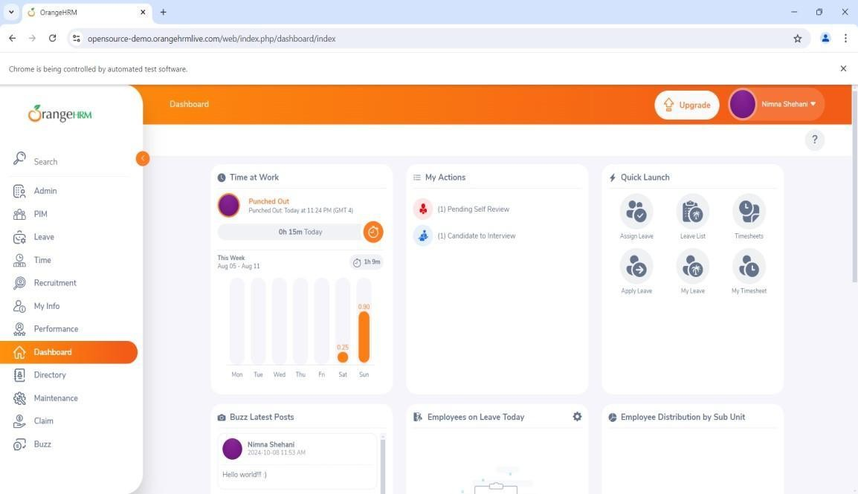

**b.Explicitly wait**

package Lathika98;

import java.time.Duration; import org.openqa.selenium.By;

import org.openqa.selenium.WebDriver;

import org.openqa.selenium.firefox.FirefoxDriver;

import org.openqa.selenium.support.ui.ExpectedConditions; import org.openqa.selenium.support.ui.WebDriverWait;

public class Practical3 {

public static void main(String[] args) throws Exception {

System.setProperty( "webdriver.gecko.driver", "C:\\selenium web

driver\\ChromeDriver\\chromedriver-win64\\chromedriver-win64\\geckodriver.exe"

);

WebDriver wd = new FirefoxDriver(); wd.get("https://opensource-demo.orangehrmlive.com/");

WebDriverWait wt = new WebDriverWait(wd, Duration.ofSeconds(30));

wt.until(ExpectedConditions.visibilityOfElementLocated(By.name("username"))).sendKeys("admin");

wt.until(ExpectedConditions.visibilityOfElementLocated(By.name("password"))).sendKeys("admin1 23");

wt.until(ExpectedConditions.visibilityOfElementLocated(By.className("oxd-button"))).click();

wt.until(ExpectedConditions.elementToBeClickable(By.className("oxd-userdropdown-tab"))).click ();

Thread.sleep(5000); wt.until(ExpectedConditions.elementToBeClickable(By.partialLinkText("Logout"))).click();

}

}

**OUTPUT :**

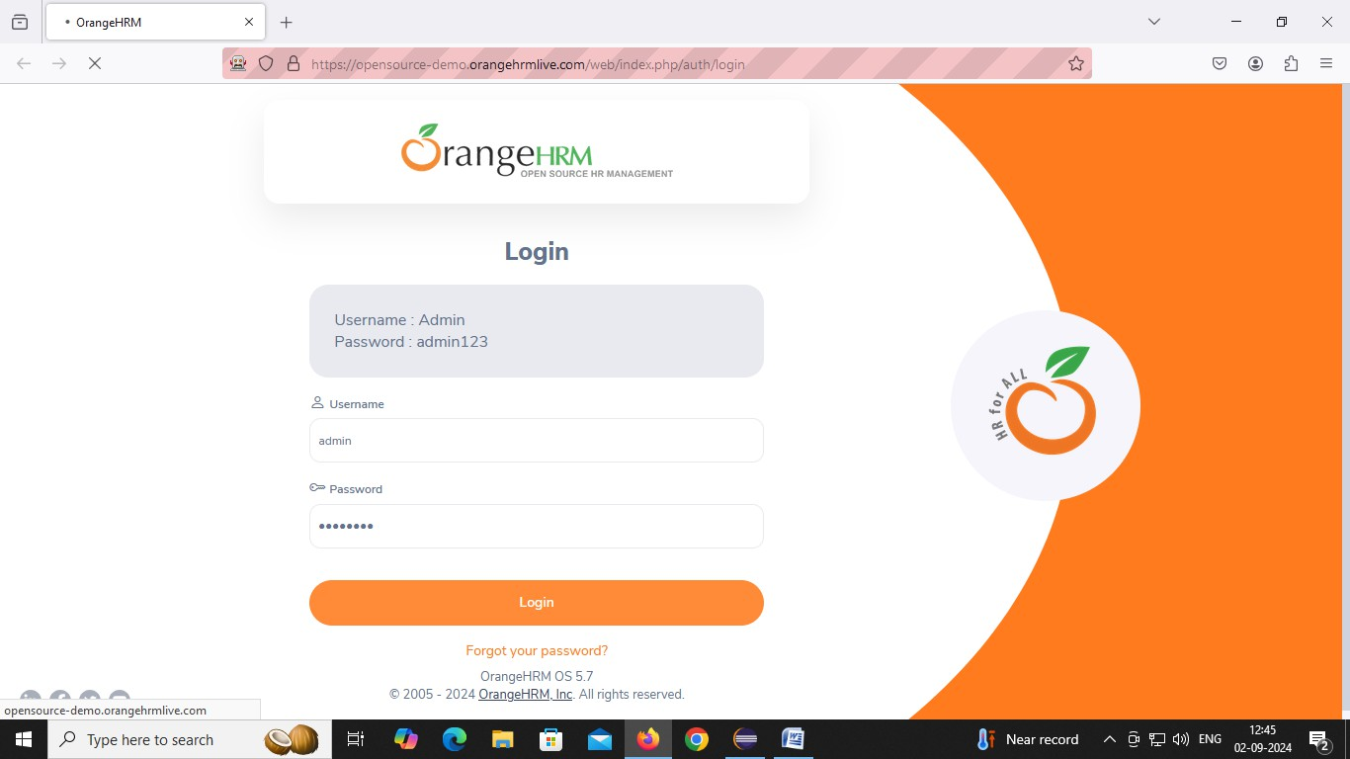

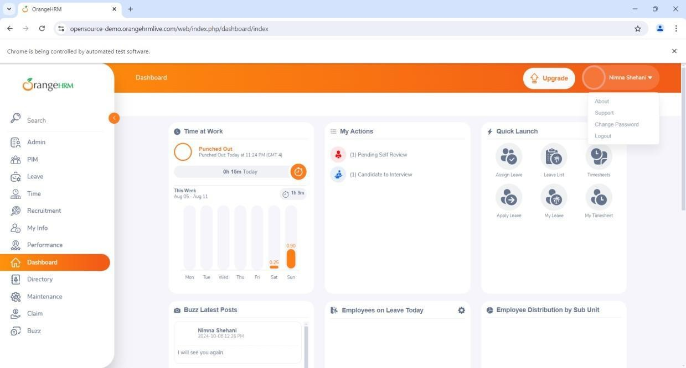

## Practical No : 8

## Aim:- Demonstrate Different types of alerts.

**CODE :**

package Lathika98;

import org.openqa.selenium.By;

import org.openqa.selenium.WebDriver; importorg.openqa.selenium.chrome.ChromeDriver; import org.openqa.selenium.firefox.FirefoxDriver; import org.openqa.selenium.support.ui.Select; publicclass alert {

Public static void main(String[] args)

{

System.setProperty("webdriver.chrome.driver","C:\\selenium web driver\\ChromeDriver\\chromedriver-win64\\chromedriver-win64\\geckodriver.exe");

WebDriver wd = new FirefoxDriver(); wd.get("https://demo.frontaccounting.eu/"); wd.findElement(By.name("user_name_entry_field")).sendKeys(""); wd.findElement(By.name("password")).sendKeys("");

Select s = new Select(wd.findElement(By.name("company_login_name"))); wd.findElement(By.name("SubmitUser")).click();

wd.findElement(By.xpath("/html/body/table[1]/tbody/tr/td/table[1]/tbody/tr/td/div[2]/table/tbody/tr [1]/t d/table/tbody/tr[2]/td[1]/a[1]")).click();

String Pid = wd.getWindowHandle();//getting id of current page System.out.println("Parent Window > " + Pid);

Select s1 = new Select(wd.findElement(By.name("customer_id"))); s1.selectByVisibleText("Donald Easter"); wd.findElement(By.name("CancelOrder")).click();

}

}

**OUTPUT :**

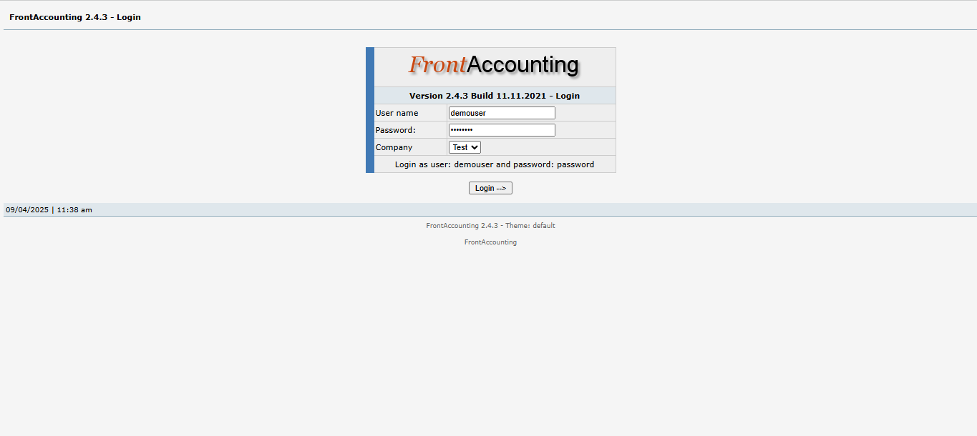

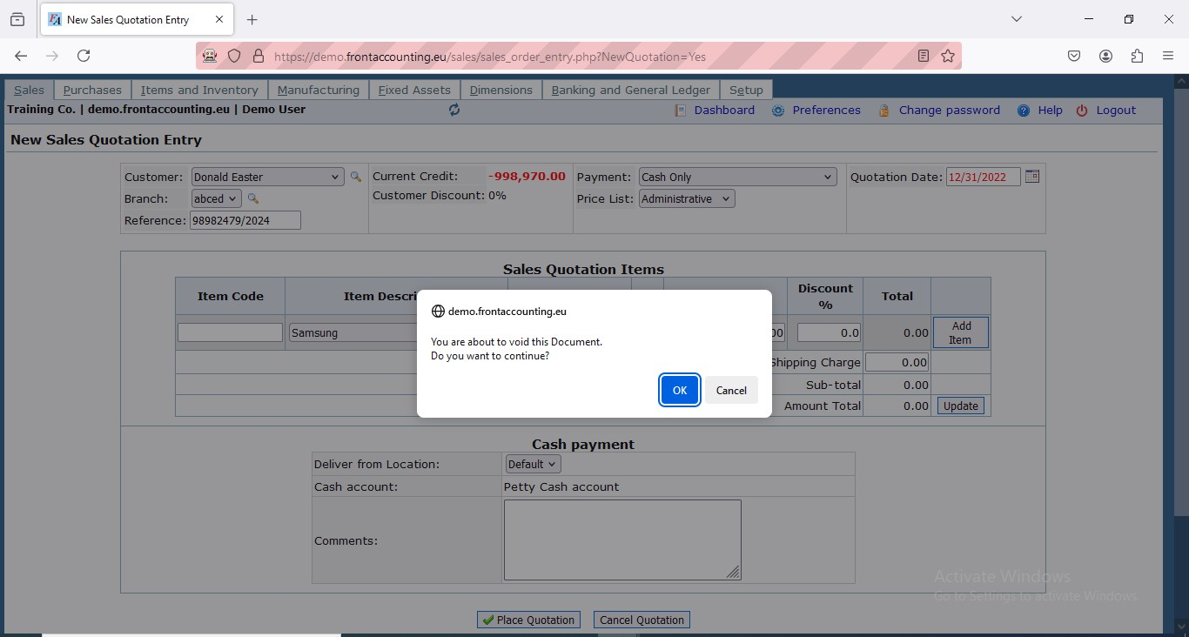

## Practical No : 9

**Aim : Demonstrate wait command in selenium.**

**CODE :**

|  |
| --- |
| package Lathika98;  import org.openqa.selenium.By;  import org.openqa.selenium.WebDriver;  importorg.openqa.selenium.firefox.FirefoxDriver; import org.openqa.selenium.support.ui.Select;  import org.openqa.selenium.support.ui.WebDriverWait; import org.openqa.selenium.support.ui.ExpectedConditions; import java.time.Duration;  public class OrderPlace {  public static void main(String[] args) { System.setProperty("webdriver.gecko.driver",  "C:\\selenium web driver\\ChromeDriver\\chromedriver-win64\\geckodriver.exe");  WebDriver wd = new FirefoxDriver(); wd.get("https://demo.frontaccounting.eu/");  WebDriverWait wait = new WebDriverWait(wd, Duration.ofSeconds(10)); wait.until(ExpectedConditions.visibilityOfElementLocated(  By.name("user_name_entry_field"))).sendKeys("your_username"); wait.until(ExpectedConditions.visibilityOfElementLocated(  By.name("password"))).sendKeys("your_password"); Select companySelect = new  Select(wd.findElement(By.name("company_login_name"))); wd.findElement(By.name("SubmitUser")).click(); wait.until(ExpectedConditions.elementToBeClickable(By.xpath(  "/html/body/table[1]/tbody/tr/td/table[1]/tbody/tr/td/div[2]/table/tbody/tr[1]/td/table/tbody/ tr[2]/td[1]/a[1]"  ))).click();  Select customerSelect = new Select(wd.findElement(By.name("customer_id"))); customerSelect.selectByVisibleText("Donald Easter"); wd.findElement(By.name("AddItem")).click(); wd.findElement(By.name("ProcessOrder")).click();  wd.quit();  }  } |

**OUTPUT :**

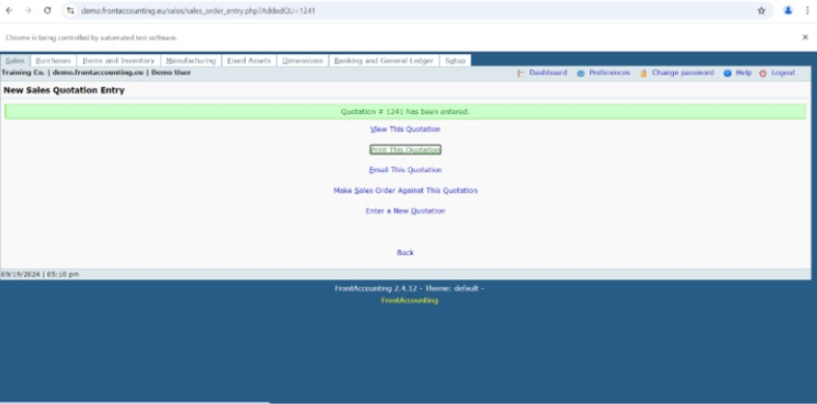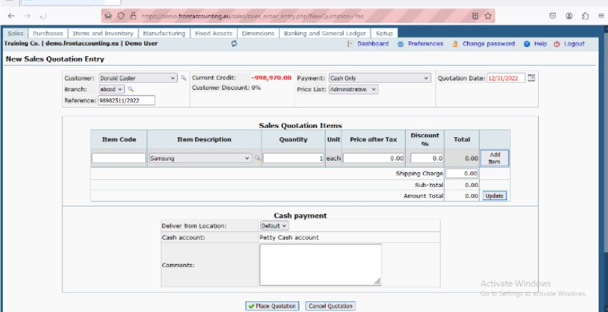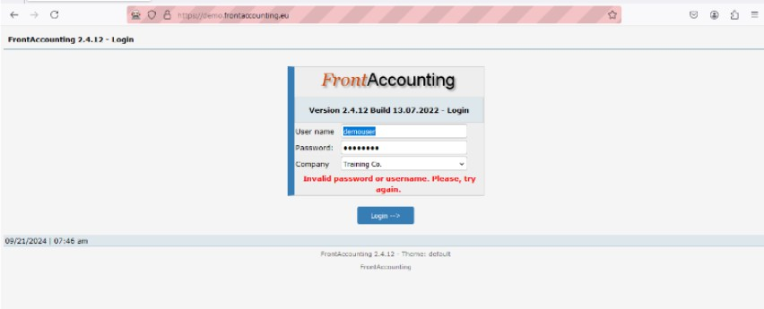

**Practical No : 10**

# **Aim : Multiple Window Handling.**

**CODE:**

|  |
| --- |
| package Lathik98; import java.util.Set;  import org.openqa.selenium.By;  import org.openqa.selenium.WebDriver;  import org.openqa.selenium.firefox.FirefoxDriver; import org.openqa.selenium.support.ui.Select; public class MultipleWindowHandling {  public static void main(String[] args) {  //Set the path for GeckoDriver (since you're using Firefox) System.setProperty("webdriver.gecko.driver",  "C:\\selenium web driver\\ChromeDriver\\chromedriver-win64\\geckodriver.exe"); WebDriver wd = new FirefoxDriver();  // Open FrontAccounting demo site wd.get("https://demo.frontaccounting.eu/");  // Login wd.findElement(By.name("user_name_entry_field")).sendKeys("your_username"); //  Replace with valid username wd.findElement(By.name("password")).sendKeys("your_password"); // Replace with  valid password  // Select company (if required)  Select s = new Select(wd.findElement(By.name("company_login_name")));  // s.selectByVisibleText("Default Company"); // Uncomment if needed wd.findElement(By.name("SubmitUser")).click();  // Click link to open a new window wd.findElement(By.xpath(  "/html/body/table[1]/tbody/tr/td/table[1]/tbody/tr/td/div[2]/table/tbody/tr[1]/td/table/tbody/tr[2]  /td[1]/a"  )).click();  // Get parent window ID  String parentId = wd.getWindowHandle(); System.out.println("Parent Window: " + parentId);  // Click a link that opens another window wd.findElement(By.xpath(  "/html/body/table[1]/tbody/tr/td/table[1]/tbody/tr/td/div[2]/form/center[1]/table/tbody/tr/td[2]/t able/tbody/tr[1]/td[2]/a"  )).click();  // Handle all window IDs  Set<String> allWindows = wd.getWindowHandles(); for (String windowId : allWindows) {  wd.switchTo().window(windowId); System.out.println("Window Title: " + wd.getTitle()); if (!windowId.equals(parentId)) {  // Perform actions in the new window  Select ss = new Select(wd.findElement(By.id("customer_id"))); // Ensure ID is  correct  ss.selectByVisibleText("Donald Easter"); wd.manage().window().maximize();  wd.close(); // Close the child window after work  }  }  // Switch back to parent window wd.switchTo().window(parentId);  // Logout wd.findElement(By.linkText("Logout")).click();  // Close browser wd.quit();  }  } |

**OUTPUT :**



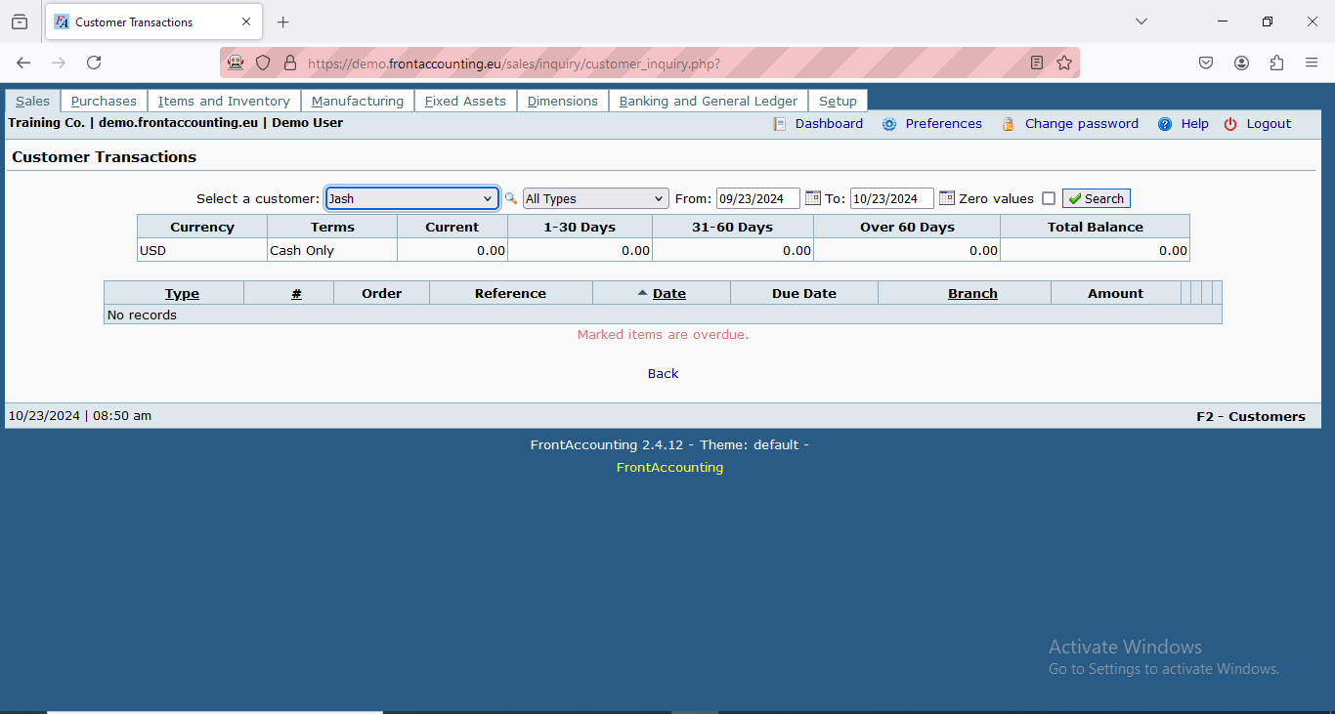

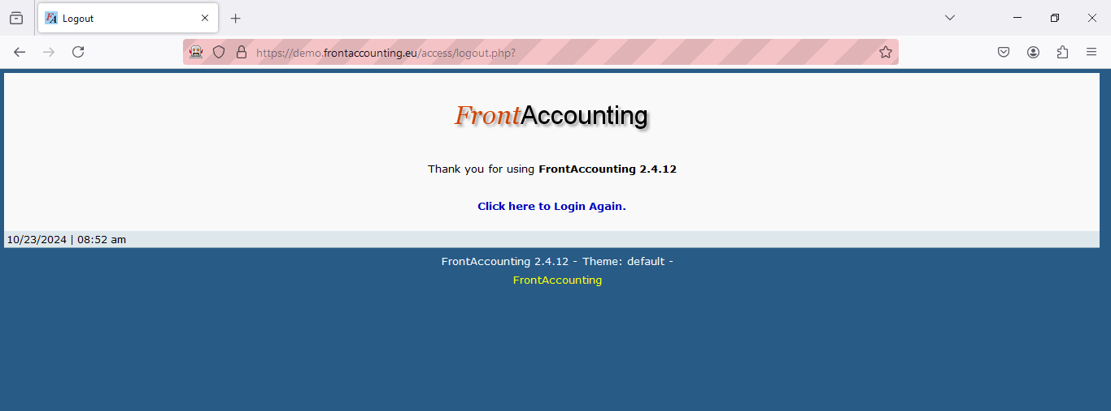

## Practical No : 11

**Aim : TestNG**

1. **Demo DataProvider**

|  |
| --- |
| package testNG;  import org.testng.annotations.DataProvider;  import org.testng.annotations.Test;  public class Pract12 {  @Test(dataProvider = "dp") public void f(Integer n, String s) {  System.out.println(n + " " + s);  }  @DataProvider  public Object[][] dp() {  return new Object[][] {  new Object[] {  1,  "A"  },  new Object[] {  2,  "B"  },  new Object[] {  3,  "C"  },  new Object[] {  4,  "Lathika"  },  };  }  } |

**OUTPUT :**

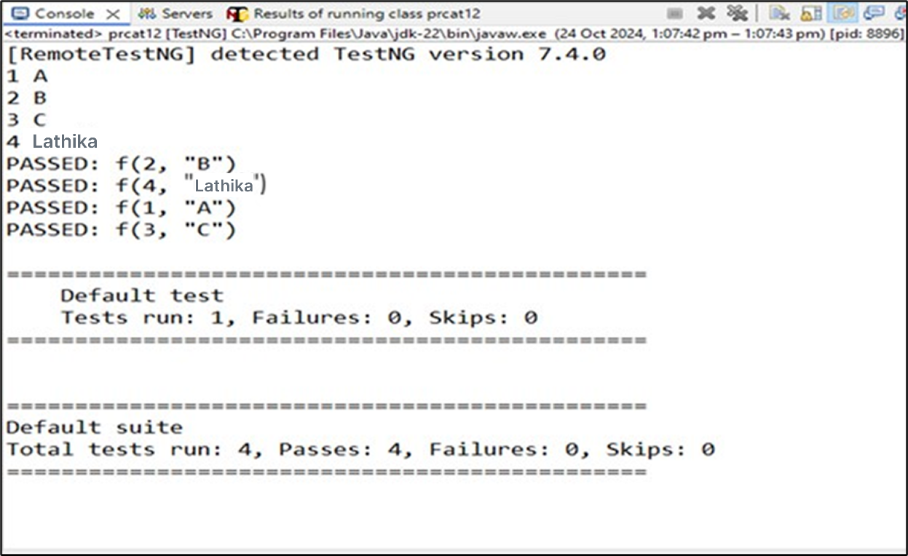

1. **Demo Annotation**

|  |
| --- |
| package testNG;  import org.testng.annotations.Test;  import org.testng.annotations.BeforeMethod;  import org.testng.annotations.AfterMethod;  import org.testng.annotations.BeforeClass;  import org.testng.annotations.AfterClass;  import org.testng.annotations.BeforeTest;  import org.testng.annotations.AfterTest;  import org.testng.annotations.BeforeSuite;  import org.testng.annotations.AfterSuite;  public class Pract12B {  @Test  public void f() {  System.out.println("Roll no: 98");  }  @BeforeMethod  public void beforeMethod() {  System.out.println("Before Method");  }  @AfterMethod  public void afterMethod() {  System.out.println("After Method");  }  @BeforeClass  public void beforeClass() {  System.out.println("Before Class");  }  @AfterClass  public void afterClass() {  System.out.println("After Class");  }  @BeforeTest  public void beforeTest() {  System.out.println("Before Test");  }  @AfterTest  public void afterTest() {  System.out.println("After Test");  }  @BeforeSuite  public void beforeSuite() {  System.out.println("Before Suite");  }  @AfterSuite  public void afterSuite() {  System.out.println("After Suite");  }  } |

**OUTPUT :**

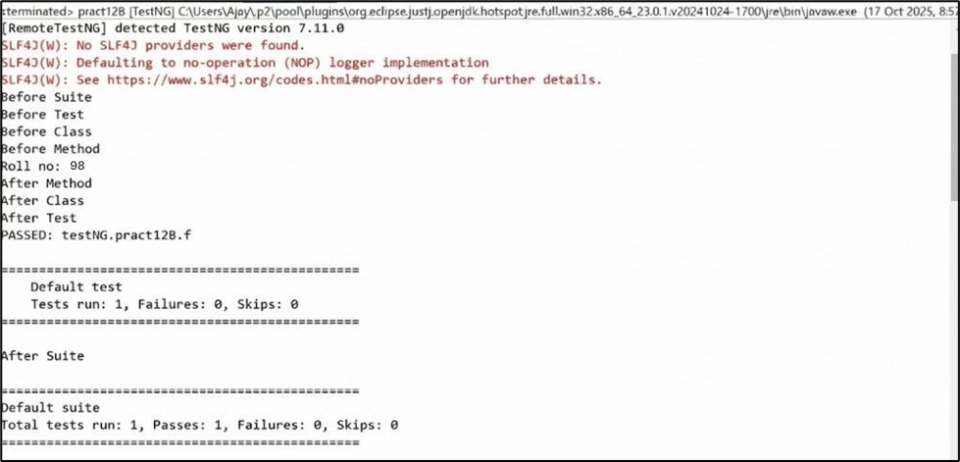

1. **Data OHM**

|  |
| --- |
| package testNG;  import java.util.concurrent.TimeUnit;  import org.openqa.selenium.By;  import org.openqa.selenium.WebDriver;  import org.openqa.selenium.firefox.FirefoxDriver;  import org.testng.annotations.Test;  import org.testng.annotations.DataProvider;  public class pracat12C {  @Test(dataProvider = "dp") public void f(String u, String p) {  System.setProperty("webdriver.gecko.driver", "C:\\selenium web  driver\\ ChromeDriver\\ chromedriver - win64\\ chromedriver - win64\\ geckodriver.exe "); WebDriver wd = new FirefoxDriver();  wd.get("https://opensource-demo.orangehrmlive.com/"); wd.manage().timeouts().implicitlyWait(10, TimeUnit.SECONDS);  wd.findElement(By.name("username")).sendKeys(u); // locator name wd.findElement(By.name("password")).sendKeys(p); // locator name wd.findElement(By.c  try {  wd.findElement(By.className("oxd-userdropdown-name")).click();  wd.findElement(By.className("oxd-userdropdown-link")).click();  System.out.println("Pass");  } catch (Exception e) {  System.out.println("Fail");  } finally {  wd.quit();  }  }  @DataProvider  public Object[][] dp() {  return new Object[][] {  {  "Admin",  "admin123"  }, {  "add",  "b"  }  };  }  } |

**OUTPUT :**

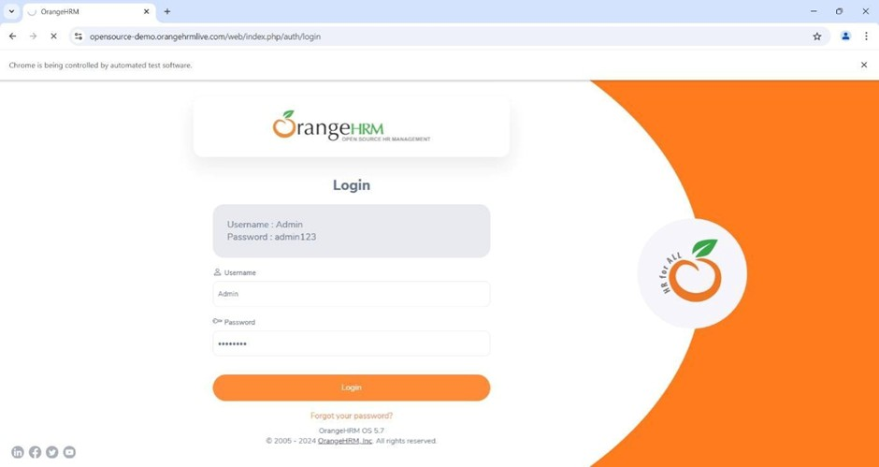

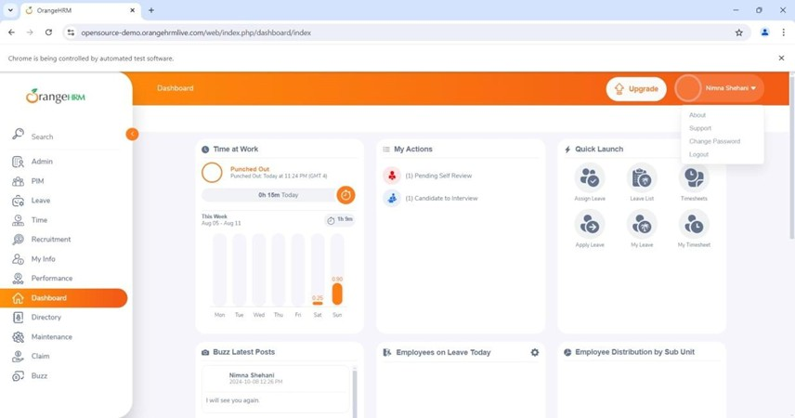

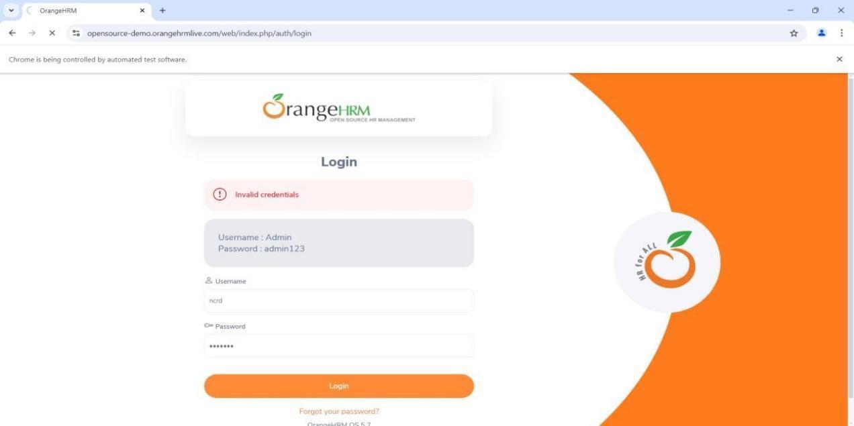

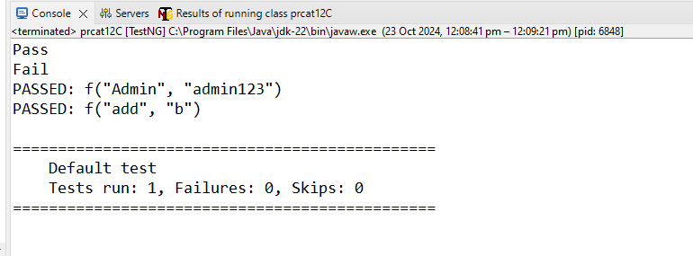

1. **DataCheck**

|  |
| --- |
| package testNG;  import org.openqa.selenium.By;  import org.openqa.selenium.WebDriver;  import org.openqa.selenium.firefox.FirefoxDriver; import org.testng.Assert;  import org.testng.annotations.Test; public class pract12D {  @Test(description = "Checking status of checkbox") public void CheckBox() {  System.setProperty("webdriver.gecko.driver", "C:\\selenium web  driver\\ChromeDriver\\chromedriver-win64\\chromedriver-win64\\geckodriver.exe"); WebDriver wd = new FirefoxDriver();  wd.get("https://mail.rediff.com/cgi-bin/login.cgi");  Boolean sts = wd.findElement(By.name("remember")).isSelected(); Assert.assertTrue(sts, "Checkbox is not selected!");  wd.quit();  }  } |

**OUTPUT :**

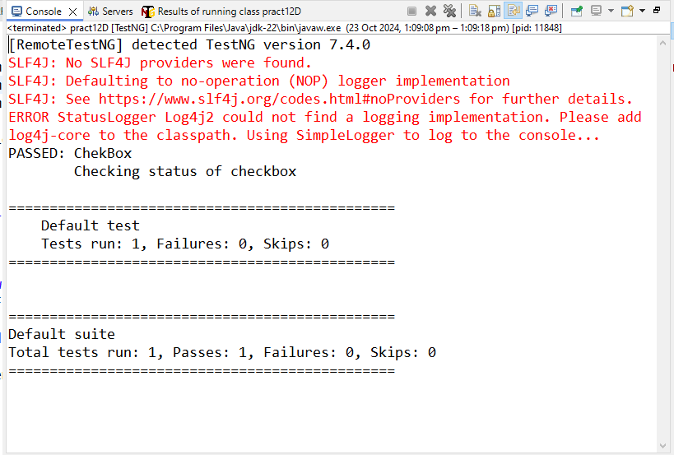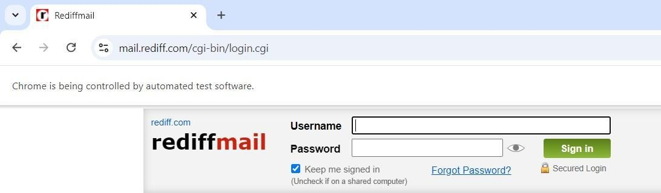

1. **DemoAssertFA**

|  |
| --- |
| package testNG;  import org.openqa.selenium.WebDriver;  import org.openqa.selenium.firefox.FirefoxDriver;  import org.testng.Assert;  import org.testng.annotations.Test;  public class pract12E {  @Test  public void frontAccounting() {  System.setProperty("webdriver.gecko.driver",  "C:\\selenium web  driver\\ ChromeDriver\\ chromedriver - win64\\ chromedriver - win64\\ geckodriver.exe "); WebDriver wd = new FirefoxDriver(); wd.get("  https: //demo.frontaccounting.eu/index.php");  String expectedTitle = "FrontAccounting 2.4.12 - Login"; // if title is not matching, execution will fail  String actualTitle = wd.getTitle(); Assert.assertEquals(actualTitle, expectedTitle, "Title does not match!"); System.out.println("Title of Webpage =====> " + actualTitle); wd.quit();  }  } |

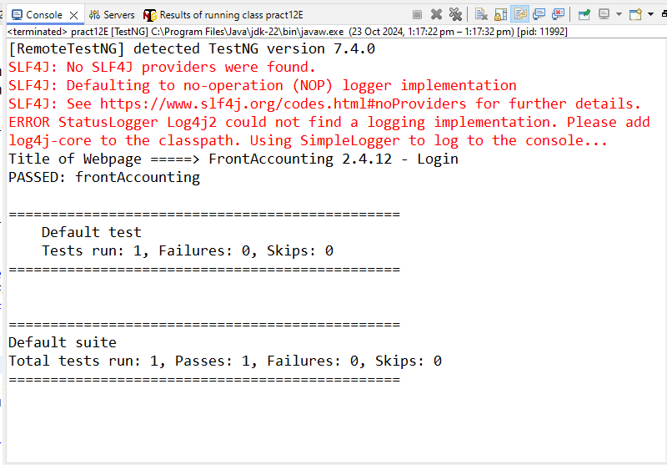**OUTPUT :**

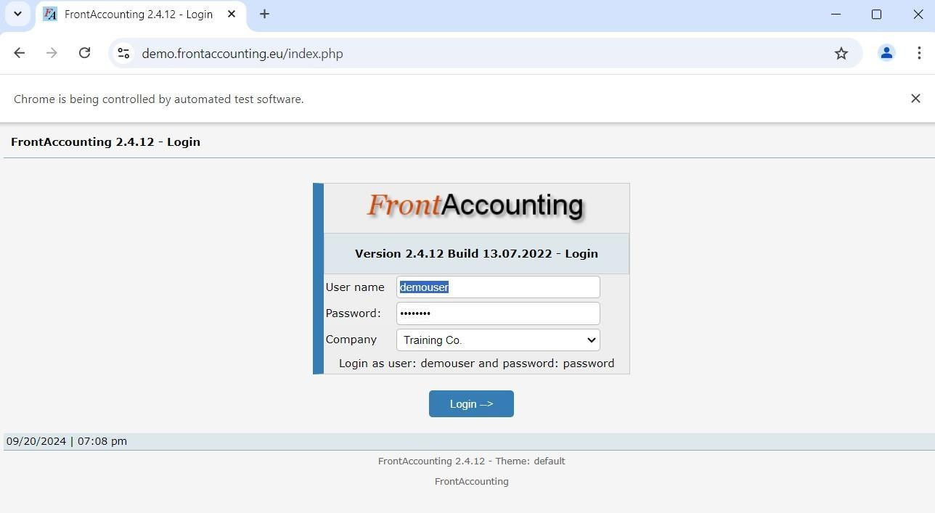

1. **DemoAlert**
   1. **Alertbox**

package testNG;

import org.openqa.selenium.Alert; import org.openqa.selenium.By;

import org.openqa.selenium.WebDriver;

import org.openqa.selenium.firefox.FirefoxDriver; public class pract12F1 {

public static void main(String[] args) throws Exception { System.setProperty("webdriver.gecko.driver",

"C:\\selenium web

driver\\ChromeDriver\\chromedriver-win64\\chromedriver-win64\\geckodriver.exe"); WebDriver wd = new FirefoxDriver(); wd.get("https://vinothqaacademy.com/alert-and-popup/");

wd.findElement(By.name("alertbox")).click(); Thread.sleep(2000);

Alert alt = wd.switchTo().alert();

System.out.println("Text of Alert: " + alt.getText()); // capture alert text alt.accept(); // click on OK button

wd.quit();

}

}

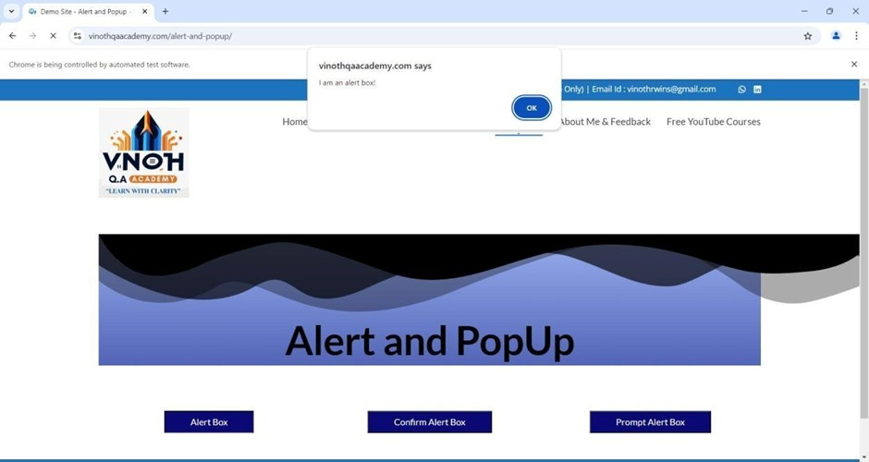**OUTPUT :**

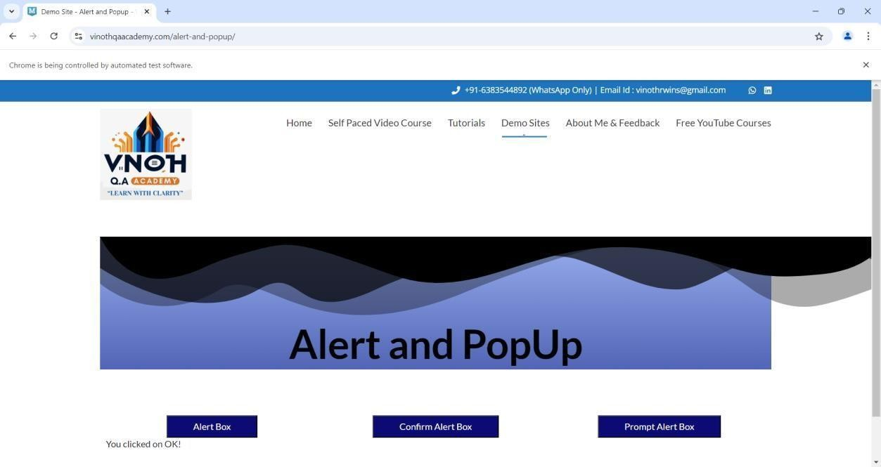

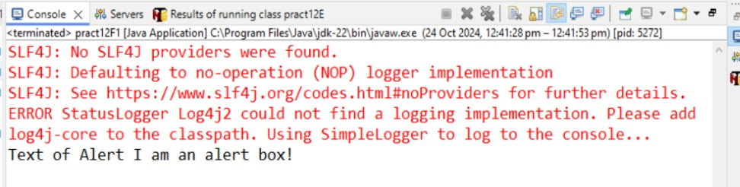

## Practical No : 12

**Aim : Demonstrate data driven Framework**

1) File read data from Excel and perform testing using selenium.

package rupali87;

import java.io.FileInputStream; import java.io.IOException;

import org.apache.poi.xssf.usermodel.XSSFCell; import org.apache.poi.xssf.usermodel.XSSFRow; import org.apache.poi.xssf.usermodel.XSSFSheet; import org.apache.poi.xssf.usermodel.XSSFWorkbook;

// Get Data From Excel public class Eighth_1 {

public static void main(String[] args) throws IOException { FileInputStream fis = new FileInputStream("D:\\STQA\\Excel1.xlsx"); XSSFWorkbook wb = new XSSFWorkbook(fis);

XSSFSheet sh = wb.getSheet("Sheet1");

for (int i = 1; i <= sh.getLastRowNum(); i++) { XSSFRow rw = sh.getRow(i);

XSSFCell un = rw.getCell(0); XSSFCell pw = rw.getCell(1); XSSFCell rs = rw.getCell(2);

System.out.println("Username ---> " + un + " Password ---> " + pw + " Result ---> " +

rs);

}

wb.close();

fis.close();

}

}

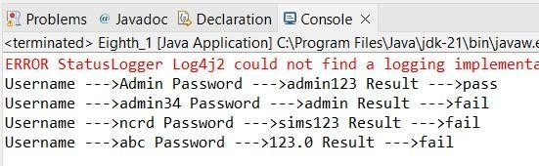

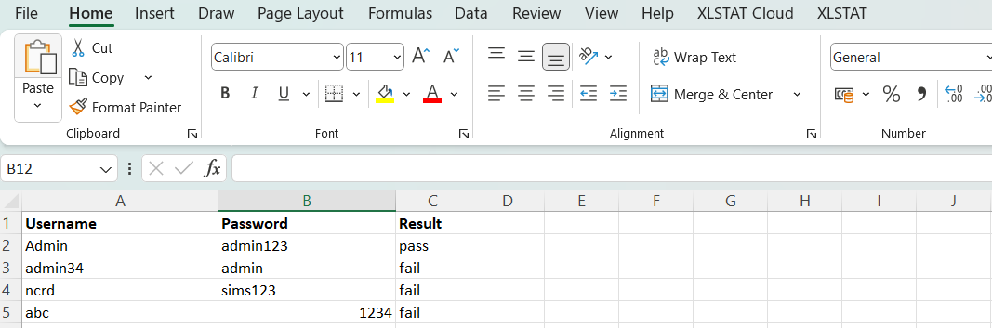





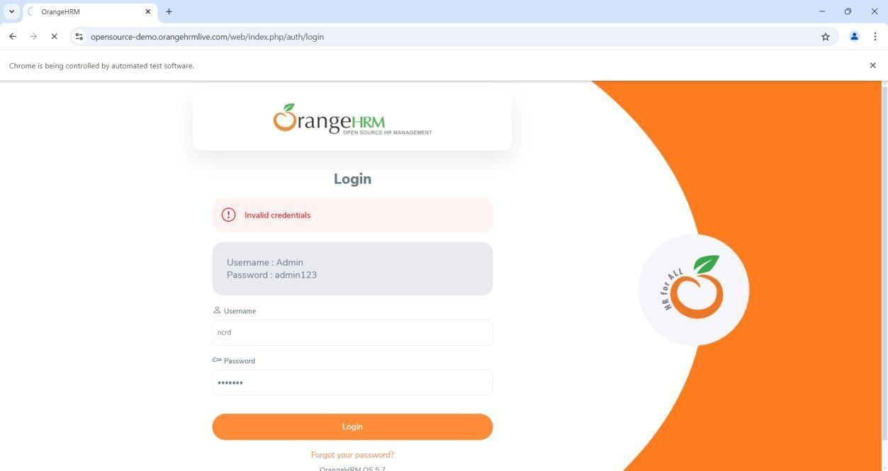

## Practical No : 13

**Aim : Write a Program to Read data from an Excel file and login in to site.**

**CODE :**

|  |
| --- |
| package lathika98;  import java.io.FileInputStream; import java.io.FileOutputStream; import java.io.IOException;  import java.util.concurrent.TimeUnit;  import org.apache.poi.xssf.usermodel.XSSFCell; import org.apache.poi.xssf.usermodel.XSSFRow; import org.apache.poi.xssf.usermodel.XSSFSheet; import org.apache.poi.xssf.usermodel.XSSFWorkbook; import org.openqa.selenium.By;  import org.openqa.selenium.WebDriver;  import org.openqa.selenium.chrome.ChromeDriver; public class Eighth_3 {  public static void main(String[] args) throws IOException { System.setProperty("webdriver.chrome.driver",  "D:\\STQA\\Selenium\\chromedriverwin64\\chromedriver.exe"); WebDriver wd = new ChromeDriver(); wd.manage().timeouts().implicitlyWait(10, TimeUnit.SECONDS); wd.get("https://opensource-demo.orangehrmlive.com/"); FileInputStream fis = new FileInputStream("D:\\STQA\\Excel1.xlsx"); XSSFWorkbook wb = new XSSFWorkbook(fis);  XSSFSheet sh = wb.getSheet("WriteData"); for (int i = 1; i <= sh.getLastRowNum(); i++) {  XSSFRow rw = sh.getRow(i); XSSFCell un = rw.getCell(0); XSSFCell pw = rw.getCell(1); XSSFCell res = rw.createCell(2);  System.out.println("Username --> " + un + " | Password --> " + pw); wd.findElement(By.name("username")).clear(); wd.findElement(By.name("username")).sendKeys(un.toString()); wd.findElement(By.name("password")).clear(); wd.findElement(By.name("password")).sendKeys(pw.toString()); wd.findElement(By.className("oxd-button")).click();  try {  wd.findElement(By.className("oxd-userdropdown-name")).click(); wd.findElement(By.partialLinkText("Logout")).click(); System.out.println("Login Pass");  res.setCellValue("Valid");  } catch (Exception e) { System.out.println("Login Fail"); res.setCellValue("Invalid");  }  }  FileOutputStream fos = new FileOutputStream("D:\\STQA\\ExcelData_1.xlsx"); wb.write(fos);  fos.close();  fis.close();  wb.close();  wd.quit();  System.out.println("Test completed and results written to Excel file.");  }  } |

**OUTPUT :**



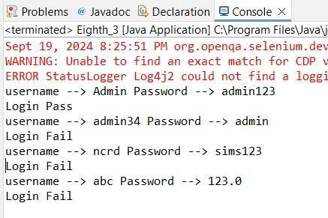



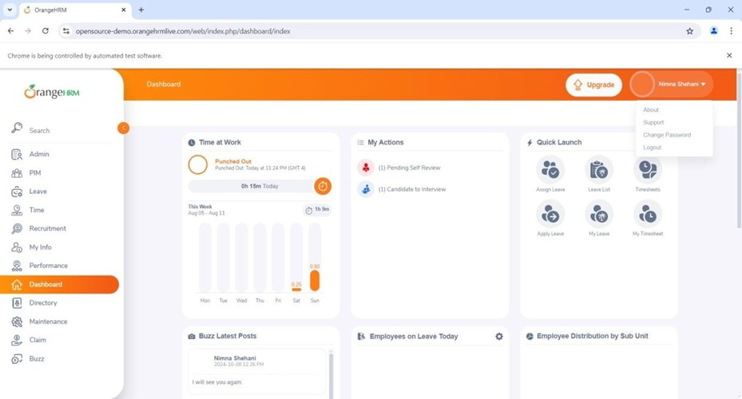

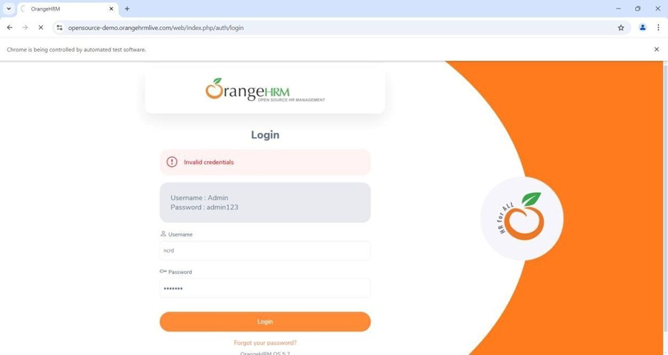

## Practical No : 14

**Aim : Validation Testing using chrome and bing.**

## Chrome

package Lathika98;

import org.openqa.selenium.By; import org.openqa.selenium.Keys;

import org.openqa.selenium.WebDriver;

import org.openqa.selenium.firefox.FirefoxDriver;

public class Practical8 {

public static void main(String[] args) throws Exception {

System.setProperty("webdriver.gecko.driver", "C:\\Selenium webdriver\\geckodriver\\geckodriver.exe");

WebDriver wd = new FirefoxDriver(); wd.get("https://google.com/");

// wd.get("https://bing.com/"); Thread.sleep(2000);

// For Firefox wd.findElement(By.className("gLFyf")).sendKeys("Fruits"); wd.findElement(By.className("gLFyf")).sendKeys(Keys.ENTER);

}

}

**OUTPUT :**

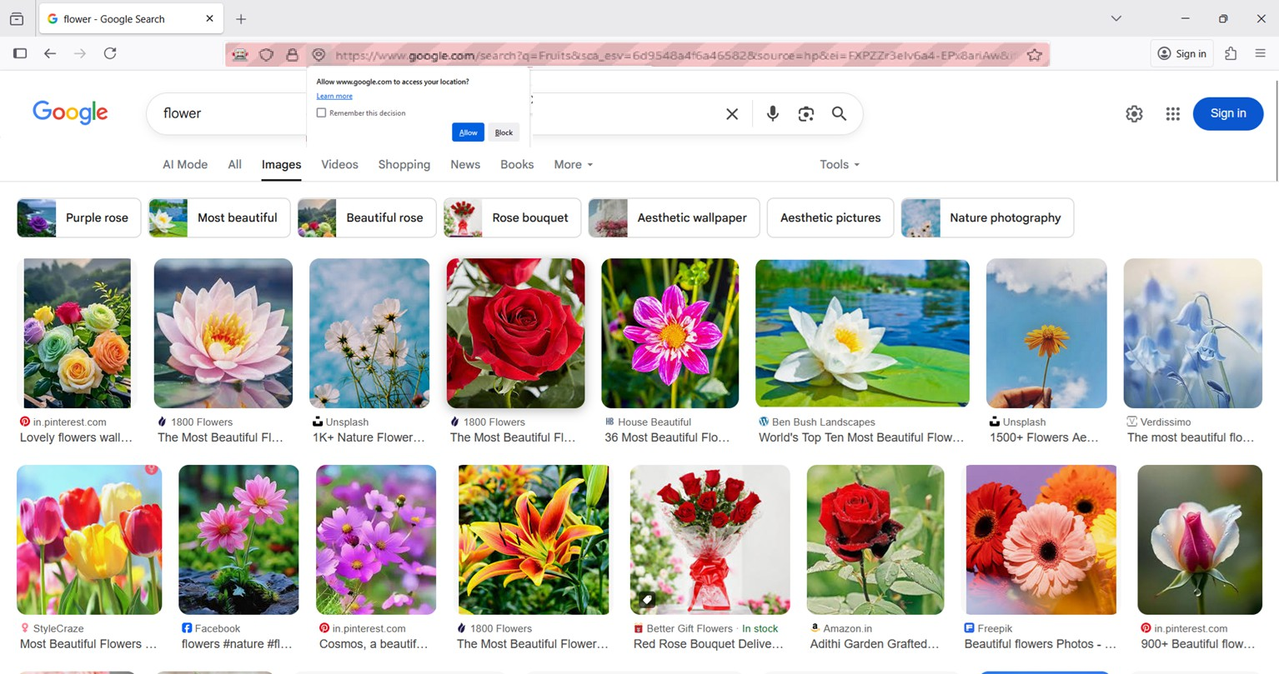

1. **Bing**

package Lathika98;

import org.openqa.selenium.By; import org.openqa.selenium.Keys;

import org.openqa.selenium.WebDriver;

import org.openqa.selenium.firefox.FirefoxDriver;

public class Practical8 {

public static void main(String[] args) throws Exception {

System.setProperty("webdriver.gecko.driver", "C:\\Selenium webdriver\\geckodriver\\geckodriver.exe");

WebDriver wd = new FirefoxDriver(); wd.get("https://google.com/");

// wd.get("https://bing.com/"); Thread.sleep(2000);

// For Firefox (Google)

// wd.findElement(By.className("gLFyf")).sendKeys("Fruits");

// wd.findElement(By.className("gLFyf")).sendKeys(Keys.ENTER);

// For Bing wd.findElement(By.className("sb_form_q")).sendKeys("Fruits"); wd.findElement(By.className("sb_form_q")).sendKeys(Keys.ENTER);

}

}

**OUTPUT :**

